Promote Partner Up for Switch Your Trips
Campaign Date: October 1-31

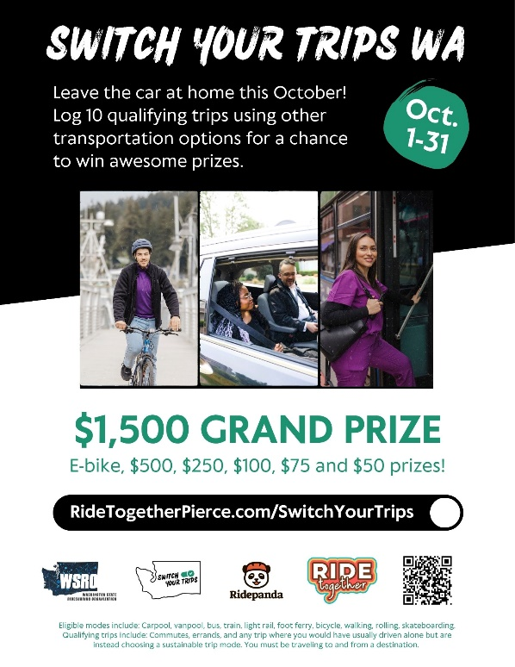
Plan Your Campaign: Now
- Recruit a committee to plan and help promote the campaign.
- Connect with your Wellness and Sustainability teams to coordinate efforts.
- Request manager support and a budget.

Promote Switch Your Trips:
September 21 – October 31
- Display the Switch Your Trips poster and PowerPoint slide and promotional video on TVs or web.
- Host a ridematching event or promote the trip planner and ridematching tool on RideTogetherPierceCalendar.com
- Order 5 ORCA cards pre-loaded with $10 and pass out to employees to try transit – even for personal trips.
- Write a commuter profile on someone who carpools, vanpools or takes transit (train, bus, light rail), walks or bikes. Share the profile in a newsletter, email, or on company Intranet page.
  - Highlight a sustainable commuter of the week.
  - Ask employees to post pictures of their sustainable commute trips on your intranet, employee engagement platforms, or social media.
    - Employees can submit a commuter profile on the RTP website. Published profile submissions earn $20.
    - Employees can share a sustainable travel photo on Facebook and Instagram and tag @RideTogetherPierce to win a $10 Starbucks gift card.
- Share Ride Together Pierce’s campaign posts on Facebook and Instagram.
- Submit a blog post for your September and October employee newsletter.
- Use sample email messages to encourage employees to participate in Switch Your Trips.
- Involve leadership by asking them to pledge to use sustainable commute modes.
- Ask leadership to deliver prizes or present prizes to campaign winners at staff meeting.
- Surprise sustainable commuters with additional prizes from your own budget, or host a breakfast/snack station for them.
- Hold individual or team challenges. Have employees earn points for prizes. Pull reports on employee trips logged.
- Get families involved by creating family activities such as encouraging carpooling or taking transit to local events and gatherings.
- Hold a prize drawing for everyone who takes a sustainable commute during Switch Your Trips.
  - This can include team challenges between departments/floors/transportation mode.
  - Prizes can include snacks, gift cards, lunch, or even commute-themed items such as gloves, umbrella, hat, headphones, audiobook or e-book memberships, tickets to local events, breakfast with the CEO, company merchandise, vouchers to the company café or vending machine.
After the Campaign: November 1 - 7
- November 7 is the last day for employees to record their trips in the online trip calendar.
- On November 8, conduct your worksite prize drawing using the calendar Reports tool.

Countywide Prize Drawing: Mid-to-late November
- All prize winners will be posted at RideTogetherPierce.com by the end of November.
  - Because this campaign is statewide, the prize drawings take longer to conduct at such a large scale. And we are unable to determine the exact day the results will be posted.
- By the end of November, announce your campaign results and winners. Include the photos of the winners and/or the commuter profile in your announcement.
- There will be two sets of prizes: Ride Together Pierce prizes and statewide prizes.
  - Winners of the Ride Together Pierce prizes will receive their prize email from the trip calendar.
  - Winners of the statewide prizes will receive an email from Tango Rewards.
Resources
- Carpool – The Employee Transportation Coordinator can help employees find coworkers who may live along their commute.
- Vanpool – You only need three people to start a vanpool. They can be your coworkers or other commuters traveling a similar route. Find existing vanpools under “Your Commute Options”.
- Bus – Bring exact cash, tap to pay, or purchase an ORCA card for easy boarding.
- Light Rail – Walk, bus, bike to hop on light rail for your next excursion. You can bring your bike on board! Travel within Tacoma, or from SeaTac to Lynnwood.
- Sounder Train – Great for commuting or leisure, the Sounder Train also runs for special events including Seahawks games!
- Walk – Sneak in some exercise that you might not have time for otherwise and arrive at work alert and ready to go.
- Bike – No matter what kind of bike rider you are, new or seasoned, bicycling is an excellent choice for the environment, your health and your cash flow.

